Customer Churn Prediction Model

1. Problem Statement
In subscription-based businesses, customer retention plays a crucial role in sustaining revenue and long-term growth. One of the major challenges faced by such businesses is identifying customers who are likely to churn before their subscription renewal date, so that timely intervention strategies can be implemented. Early identification of at-risk customers enables organizations to take proactive measures such as offering discounts, resolving complaints, improving engagement, and strengthening customer relationships.
This project aims to develop a machine learning model to predict whether a customer will churn 45 days prior to their subscription renewal date. To ensure realistic and reliable predictions, the model utilizes customer data within a defined time window — specifically, from 6 months before the renewal date up to 45 days prior to renewal. This approach ensures that only relevant historical information is considered while preventing data leakage, thereby making the model suitable for real-world deployment.
2. Data Sources
2.1 Billings Dataset
The Billings dataset serves as the primary dataset and contains core customer and subscription-related information.
Key attributes include:
- Customer identifier (Co_Ref)
- Renewal date (Prospect_Renewal_Date)
- Subscription outcome (Prospect_Outcome) — target variable
- Pricing details and payment information
- Customer segmentation features such as Band, Tenure, and Group
This dataset forms the base upon which all other datasets are integrated.
2.2 Renewal Calls Dataset
This dataset contains records of interactions between customers and renewal agents during the renewal process.
Key features include:
- Call date (call_date)
- Customer responses and reactions
- Complaint categories
- Renewal discussion outcomes
This dataset is critical for extracting behavioral signals within the 45-day prediction window.
2.3 Customer Care (CC Calls) Dataset
The CC Calls dataset captures customer support interactions and provides insights into customer satisfaction and issues.
Key features include:
- Customer complaints and concerns
- Business-related issues
- Sentiment scores
- Indicators of churn intent
This dataset helps identify dissatisfaction patterns that may lead to churn.
2.4 Emails Dataset
This dataset includes email communication between the company and customers, adding an additional behavioral dimension.
Key features include:
- Email interaction frequency
- Engagement levels
- Communication patterns
The inclusion of this dataset enhances the model by incorporating digital engagement behavior, which was not present in the reference project.

3. BUSINESS UNDERSTANDING
This step establishes a clear understanding of the business problem, project objectives, and the analytical approach required to solve the churn prediction challenge. The primary goal is to identify customers who are likely to churn before their renewal date so that the business can take timely and effective retention actions.
Objective
The objective of this project is to predict whether a customer will churn during a renewal cycle using historical customer interaction data.
Unit of Analysis
Each row represents: 1 Customer × 1 Renewal Cycle
Target Variable
- Churn = 1 → Customer did not renew
- Churn = 0 → Customer renewed
Time Anchor
Prospect_Renewal_Date
Modeling Approach
Definition
Only data available before 45 days of the renewal date is used.
Time Window
Call_Date <= (Renewal_Date - 45 days)
Purpose
- Avoid data leakage
- Mimic real-world prediction
- Enable early churn detection
Business Value
Helps the business take proactive retention actions well before renewal.
4. DATA UNDERSTANDING
In this step, we explore all the provided datasets to understand their structure, content, and relationships.
The objectives of this step are:
- To examine dataset dimensions and structure
- To understand column types and meanings
- To identify missing values and inconsistencies
- To detect duplicates
- To identify key columns for joining datasets
The datasets used in this project are:
- Billings Dataset – Contains customer information, renewal details, and target variable
- Renewal Calls Dataset – Contains call interactions during the renewal process
- Emails Dataset – Contains CRM/email interaction signals
- Customer Care Calls Dataset – Contains support and complaint-related interactions
This step helps build a strong understanding of the data before proceeding to cleaning and feature engineering.

- INITIAL DATA CLEANING
In this step, we perform basic data cleaning to prepare the datasets for analysis.
The objectives of this step are:
- To correct data types (especially date columns)
- To remove duplicate records
- To handle obvious missing values
- To standardize categorical values
- To drop irrelevant or junk columns
This step ensures that the data is in a usable format for further analysis and feature engineering.
- Copy datasets
- Convert date columns
- Remove duplicates
- Drop obvious junk columns
- Standardize text
- Handle obvious missing values

AFTER CLEANING
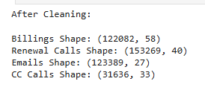
- TARGET DEFINITION AND CUTT-OFF LOGIC

This step defines the target variable where churn is labeled as 1 and renewal as 0, while excluding "Open" records since they do not represent final outcomes.A cutoff date is created as 45 days before the renewal date to ensure only past data is used.This prevents data leakage and ensures the model reflects real-world prediction conditions.
- Check Target Distribution
This step helps us understand the distribution of the target variable (Prospect_Outcome).
It allows us to:
- Identify different outcome categories
- Check class imbalance
- Detect unwanted categories (e.g., "Open")
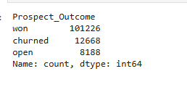
- Remove "Open" Outcomes
Rows with "Open" status are removed because they do not represent a final outcome.
"Won" → Customer renewed "Churned" → Customer did not renew "Open" → Outcome not finalized (cannot be used for training)
- Create Target Variable (churn)
We convert the categorical outcome into a numerical target variable:
churn = 1 → Customer churned churn = 0 → Customer renewed
This transformation is required for machine learning models.
- Verify Target Variable
This step ensures that the target variable has been created correctly.
It also helps confirm:
Distribution of churn vs non-churn No unexpected values
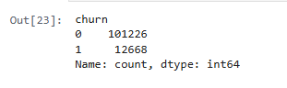
- Create Cutoff Date
A cutoff date is created to enforce time-based feature extraction.
Only data available before 45 days of the renewal date is allowed

Formula: cutoff_date = Prospect_Renewal_Date - 45 days
- Validate Cutoff Date
This step verifies that the cutoff date has been calculated correctly.
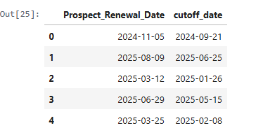
- BUILDING MODELLING DATASET
In this step, we construct the final modeling dataset by transforming raw interaction data into structured features.

The goal is to:
- Aggregate data at the customer level
- Ensure no data leakage using cutoff_date
- Combine all datasets into a single table
- Create Base Dataset
We start by copying the cleaned billing dataset.
This dataset acts as the base table because:
- It contains the target variable (churn)
- It defines the unit of analysis (1 customer × 1 renewal)
- All other datasets will be merged onto this
df = billings_clean.copy()

- Filter Renewal Calls Using Cutoff Date
We merge renewal calls with the base dataset to bring in the cutoff_date.
Then we filter the data to keep only calls that occurred within:
- 6 months before cutoff_date
- Up to the cutoff_date
This ensures:
- No future data is used
- Only relevant historical data is used
- Create Renewal Call Features
We aggregate renewal calls at the renewal level.
Grouping is done using:
- Co_Ref
- cutoff_date
This ensures:
- Each renewal is treated separately
- No mixing of multiple renewal cycles
Feature created:
- total_renewal_calls → number of renewal interactions
- Filter Customer Care Calls
We apply the same time filtering logic to customer care calls.
This dataset captures:
- complaints
- issues
- customer dissatisfaction
Only calls within the valid time window are retained.
- Create Customer Care Features
We aggregate customer care interactions at the renewal level.
Feature created:
- total_cc_calls → number of support interactions
These features help capture customer dissatisfaction patterns.
- Filter Emails Dataset
The emails dataset is already grouped by time buckets.
We select only relevant buckets:
- prior_year
- 45_out
These represent interactions before the cutoff date.
- Create Email Features
We aggregate email interactions to create:
- total_emails → number of CRM interactions
This helps capture engagement level of the customer.
- Merge All Features
We merge all generated features with the base dataset.
Merging is done using:
- Co_Ref
- cutoff_date (for renewal-level alignment)
This ensures:
- No mixing across different renewal cycles
- Handle Missing Values After Merge
After merging, some customers may not have interactions.
We replace missing values with 0:
- No calls → 0
- No emails → 0

- Final Dataset Check
We inspect the final dataset to ensure:
- Correct shape
- Features are created properly
- No unexpected issues
- BASIC FEATURE CREATION (Aggregation & Counts)
In this step, we enhance the dataset by creating additional basic features.
Objective:
- Convert raw features into more meaningful signals
- Capture intensity of customer interactions
- Create simple but powerful predictors
These features are derived using:
- Aggregations
- Counts
- Ratios
These will improve model performance and help in better pattern detection during EDA.

- Interaction Intensity Features
We combine different interaction types to measure overall engagement.
This helps capture:
- How active a customer is
- Total interaction volume
- Ratio Features
We create ratios to understand relative behavior.
This helps normalize data and compare customers better.
- Change-Based Features
We measure how customer values have changed over time.
This helps detect:
- Growth or decline
- Risk patterns
- Payment Behavior Features
We analyze payment-related patterns.
This helps capture:
- Customer commitment
- Financial behavior
- Tenure-Based Features
We use tenure to understand customer lifecycle.
Longer tenure may indicate:
- Loyalty
- Stability
Even if a tenure score exists, tenure years may still contain missing values that need to be handled carefully.
Tenure score is often a transformed or scaled version and may not fully capture the raw duration information when tenure years are missing.
In this case:
- Tenure score can be used as a proxy where tenure years are missing
- Missing tenure years can be imputed using tenure score patterns or median values
- Retaining tenure years is still useful for interpretability and feature engineering
- Engagement Flags
We convert continuous features into binary indicators.
This helps models capture thresholds easily.
- High CC Calls Flag
Reason 1: Simplify pattern
Instead of:
0,1,2,3,4,5 calls
We convert to:
LOW(0) vs HIGH(1) based on median
Reason 2: Models love simple signals
Binary features are easier for models to learn
Reason 3: Capture threshold behavior
Example:
Customers with >2 complaints churn more This feature directly captures that
9. EXPLORATORY DATA ANALYSIS (EDA)
In this step, we analyze the dataset to identify patterns and relationships with churn.
Instead of focusing only on interaction features, we analyze churn across multiple business dimensions:
- Behavioral (interactions)
- Customer Profile
- Financial
- Time / Lifecycle
- Engagement Channels
This ensures a balanced and meaningful understanding of churn drivers.
- Missing Values Analysis
We analyze missing values to understand data quality and patterns.
We do NOT handle them yet — only observe.
- Target Variable Distribution
We analyze churn distribution to check class imbalance.
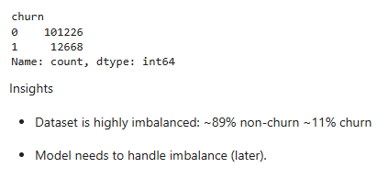
- Behavioural Analysis
We analyze customer interaction behavior and its impact on churn
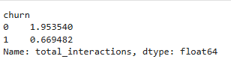
- Categorical Feature Analysis
We analyze churn across different customer segments.
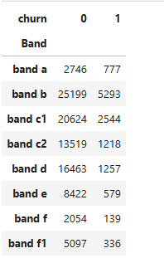
Insight
- Band B and C1 have highest churn volume
- Band A has relatively higher churn proportion
→ Band is an important segmentation feature

- Numerical Feature Distribution
We analyze distribution of numerical variables.
8 rows × 48 columns
Insight
- total_interactions median = 2 → most users have low engagement
- cc_call_ratio & renewal_call_ratio are highly skewed
- revenue_change is mostly 0 → weak signal
- connection_change mostly 0 → weak feature
- Time-Based Analysis
We analyze churn trends over time.
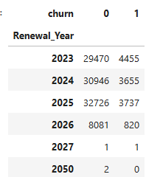
Insight
- Churn slightly decreasing from 2023 → 2026
→ Business improving OR data shift
- Correlation Analysis
We analyze relationships between numerical features.
Insight
- Strong multicollinearity between: Starting_Net, Gross, Membership_Net, Total_Amount
→ These features are redundant
- Interaction features are NOT strongly correlated with others
→ They provide unique signal
- Outlier Detection
We check extreme values in important features.
Insights
- Most customers have 0–2 calls
- Few customers have very high calls (outliers)
→ Heavy skewed distribution
10.HYPOTHESIS TESTING + STATISTICAL TESTING
In this step, we validate whether the patterns observed during EDA are statistically significant.
We define hypotheses for key feature groups:
- Behavioral features
- Customer profile
- Financial features
- Payment behavior
- Time / lifecycle
Statistical tests are used to determine whether observed differences are significant or occurred by chance.
Statistical Test Selection Rule
- Numerical feature vs churn → T-Test
- Categorical feature vs churn → Chi-Square Test
H1: Total Interactions vs Churn
H0: There is no difference in total interactions between churn and non-churn customers
H1: Total interactions differ significantly between churn and non-churn customers
H1 p-value: 0.0
H2: Low Engagement vs Churn
H0: Low engagement is independent of churn
H1: Low engagement is associated with churn
H2 p-value: 0.0
H3: Tenure vs Churn
H0: Tenure and churn are independent
H1: Tenure is associated with churn
H3 p-value: 0.0
H4: Band vs Churn
H0: Band has no relationship with churn
H1: Band significantly impacts churn
H4 p-value: 0.0
H5: Payment Method vs Churn
H0: Payment method is independent of churn
H1: Payment method significantly affects churn
H5 p-value: 0.0
H6: Renewal Year vs Churn
H0: Churn is independent of renewal year
H1: Churn varies across renewal years
H6 p-value: 3.11408213068361e-44
H7: Email Engagement vs Churn
H0: There is no difference in email interactions between churn groups
H1: Email interactions differ significantly between churn groups
H7 p-value: 0.0
11.ADVANCED CLEANING
In this step, we refine the dataset by selecting only meaningful features, handling missing values, and preparing the dataset for modeling.
We focus on retaining high-signal features across behavioral, customer profile, payment, time, and scoring dimensions while removing unnecessary or redundant columns.
- Feature Selection
We retain only the most important features identified from EDA and hypothesis testing.
These features capture:
- Customer behavior
- Engagement level
- Customer profile
- Payment patterns
- Time-based trends
- Business scoring metrics

- Handling Payment_Timeframe Missing Values
Payment_Timeframe represents the number of days between payment and renewal.
For missing values, we derive it using: Payment_Timeframe = Prospect_Renewal_Date - Closed_Date
This ensures business-consistent imputation.
- Drop Temporary Columns
After deriving Payment_Timeframe, date columns are no longer needed.
- Handling Categorical Missing Values
Missing categorical values are filled with 'Unknown'.
This preserves missingness as a meaningful signal instead of removing data.
12.ADVANCED FEATURE ENGINEERING
In this step, we extract behavioral signals from:
- Renewal Calls → customer intent, complaints, churn signals
- CC Calls → issues, dissatisfaction, sentiment
- Emails → engagement, complaints, financial stress
These features help the model understand customer behavior before churn.
13.FEATURE SELECTION
- Remove Identifier Columns
The column Co_Ref is a unique identifier for each customer.
Why we drop it:
- It does not contain any predictive information
- Models cannot learn patterns from IDs
- Keeping it may introduce noise
Therefore, it is removed before modeling.
- Remove Redundant Features
Some features represent the same information in aggregated form.
We already created detailed behavioral features such as:
- call-level signals
- email-level signals
The following columns are redundant:
- total_interactions → Already captured through individual interaction features
→ Keeping it duplicates information
- total_emails → Already represented by email_interactions
- Retain Important Features
We keep features that provide strong signals for churn prediction.
These features are grouped as follows:
3.1 Behavioral Features
These directly capture customer intent and dissatisfaction. They are the most important predictors of churn.
- negative_calls
- complaint_calls
- cancel_intent_calls
- switching_intent_calls
3.2 Customer Care Features
These represent issues raised during support interactions. They reflect dissatisfaction and service quality.
- cc_complaint_calls
- cc_financial_stress_calls
- cc_pricing_issue_calls
- cc_platform_issue_calls
- cc_support_dissatisfaction_calls
3.3 Email Features
These capture customer communication signals such as complaints, negative experience, and payment behavior.
- email_complaints
- email_negative_exp
- email_financial_issue
- email_price_issue
- low_payment_intent_count
- email_interactions
3.4 Engagement Features
These indicate customer engagement level. Low engagement is often a strong churn signal.
- cc_call_ratio
- low_engagement
3.5 Customer Profile Features
Customer Profile Features
- tenure_bucket
- Band
- Anchor_Group
- Payment_Method
- Renewal_Year
3.6 Business Scores
These are domain-specific scores reflecting customer value, renewal strength, and account status.
- Sustainability_Score
- Total_Renewal_Score_New
- Auto_Renewal_Score
- Anchoring_Score
- Tenure_Scores
3.7 Time-Based Feature
Represents how early or late the customer completed payment. This can indicate churn risk.
Payment_Timeframe
14.DATA SPLITTING (Time based)
Split data into train and test without leakage
Customer behavior changes over time
Churn rate decreases across years
So: Train on past to Predict future
- Remove Noisy Years
Years like 2027 and 2050 have very few records and do not represent real customer behavior.
Removing them ensures stable training and evaluation.
- Check Churn Trend
We verify that churn distribution is stable across years.
- Time-Based Split
We split data based on Renewal_Year:
Train → 2023, 2024
Test → 2025
Why:
- Preserves chronological order
- Avoids data leakage
- Maintains stable churn distribution
- Define Features and Target
We separate features (X) and target (y).
- Validate Split
We ensure:
- Proper dataset sizes
- Balanced churn distribution
15.ENCODING (AFTER SPLITTING)
- Identify Categorical Columns
Machine learning models require numeric input.
We convert categorical features into numeric using one-hot encoding.
- Apply One-Hot Encoding
We encode categorical variables separately for train and test data.
- Align Train and Test Columns
After encoding, train and test may have different columns.
We align them to ensure consistency.
- Final Check
We verify:
- No missing values
- Same columns in train and test
16.BASELINE MODEL
In this step, we train our first machine learning models to predict churn.
Objectives:
- Validate whether our features are meaningful
- Establish baseline performance
- Detect overfitting or underfitting
- Understand model behavior
We start with simple models:
- Logistic Regression
- Decision Tree
These models help us evaluate the quality of the dataset before using advanced models.
- Import Libraries
We import machine learning models and evaluation metrics.
- Load Saved Train/Test Data
We load previously saved datasets for modeling.
1.Logistic Regression
This model serves as the baseline. It predicts the probability of churn.
lr_model = LogisticRegression(max_iter=1000)
lr_model.fit(X_train, y_train)
Evaluation (Logistic Regression)
Metrics:
- Accuracy → overall correctness
- Recall → ability to detect churn (important)
- AUC → model discrimination ability
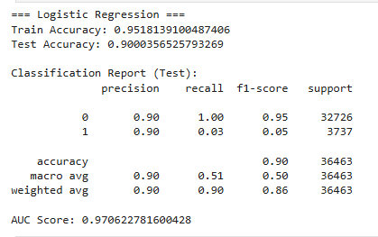
Logistic Regression with Class Weight
The dataset is imbalanced:
- Non-churn ≈ 90%
- Churn ≈ 10%
Threshold Comparison
Threshold = [0.5, 0.4, 0.3, 0.2, 0.1]
Threshold Tuning
We reduce the threshold to improve churn recall.
threshold = 0.1
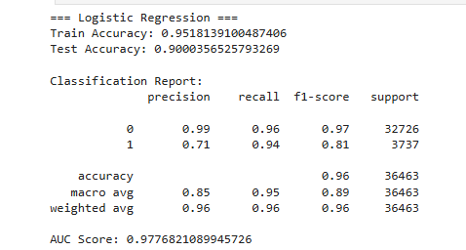

Confusion Matrix
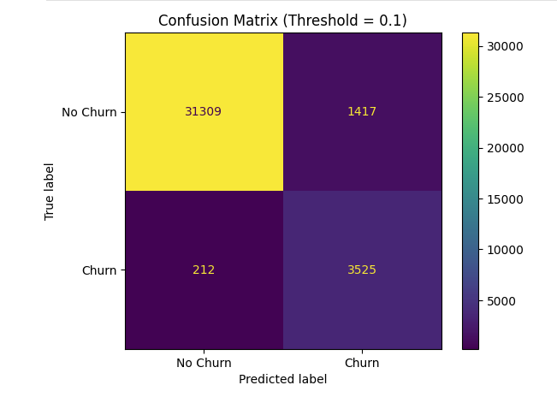
2. Decision Tree
Captures non-linear relationships between features. Depth is limited to avoid overfitting.
y_train_pred_dt = dt_model.predict(X_train)
y_test_pred_dt = dt_model.predict(X_test)
y_test_prob_dt = dt_model.predict_proba(X_test)[:, 1]
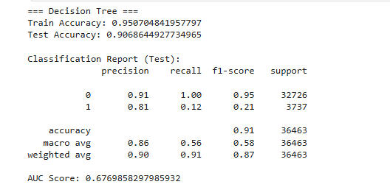
CONFUSIN MATRIX
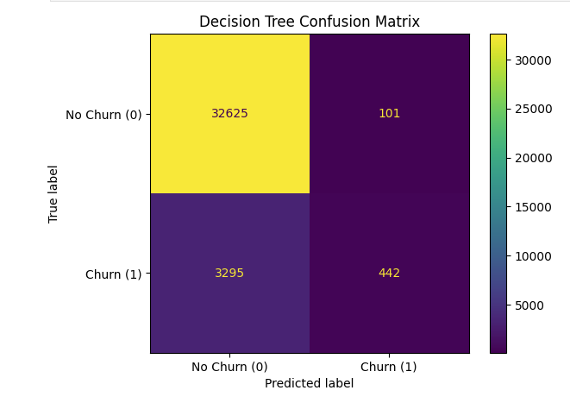
Decision Tree with Class Weight
THRESHOLD = [0.5, 0.4, 0.3, 0.2, 0.1]
THRESHOLD = 0.1
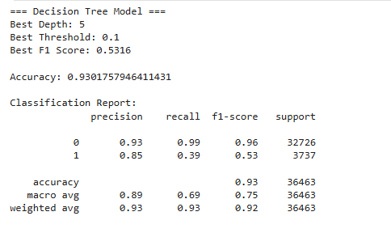

17.ADVANCED MODEL
In this step, we train advanced ensemble models to improve churn prediction.
Models used:
- XGBoost (Gradient Boosting)
- Random Forest
These models capture complex patterns and interactions between features.
XGBoost Model
XGBoost is a powerful boosting algorithm that builds trees sequentially.
It focuses on correcting previous errors and often performs better than other models.
Threshold Tuning
Threshold =[0.5, 0.3, 0.2, 0.1]
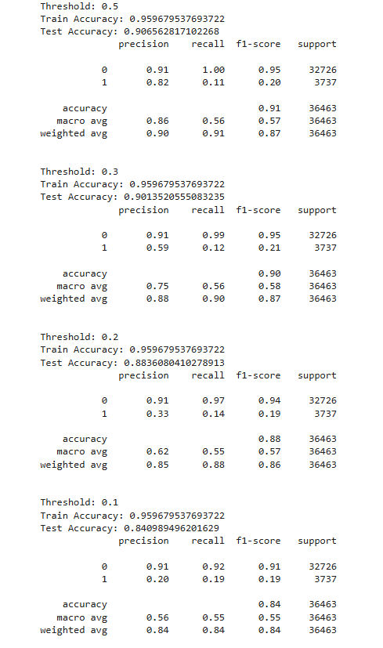

Hyperparameter Tuning for XGBOOST
1.Manual Tuning
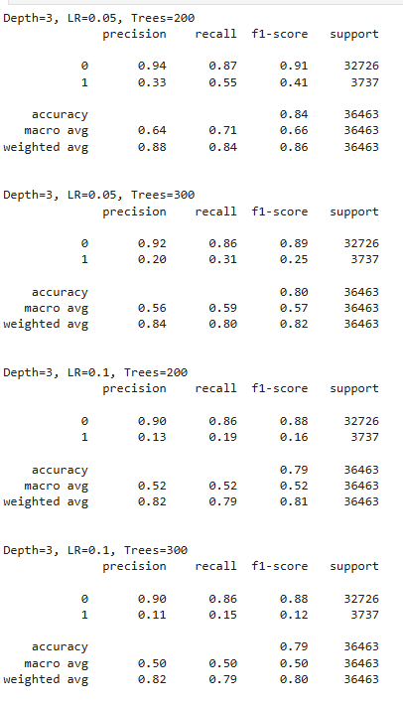

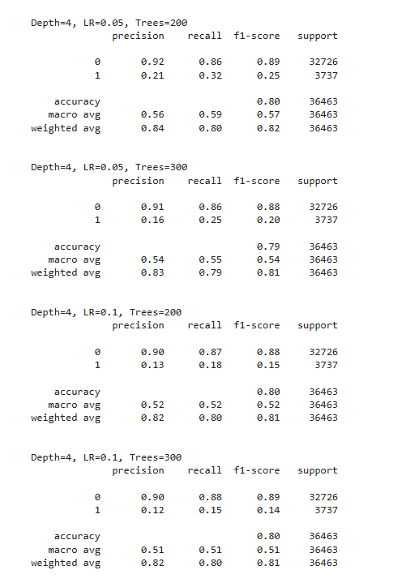

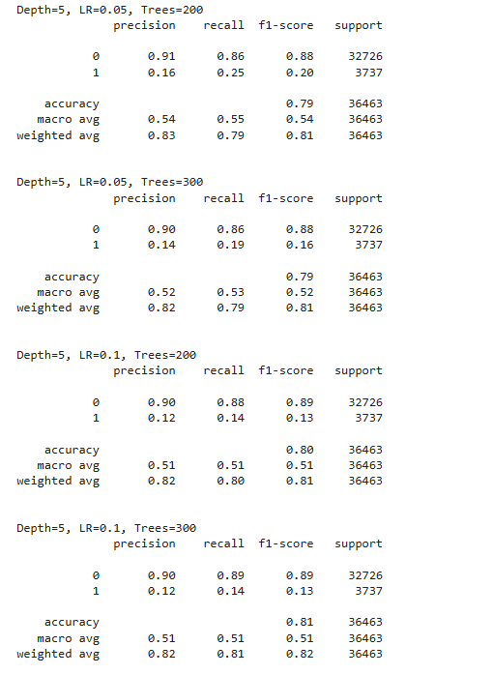

- GridSearchCV
Best Params: {'learning_rate': 0.05, 'max_depth': 3, 'n_estimators': 200}

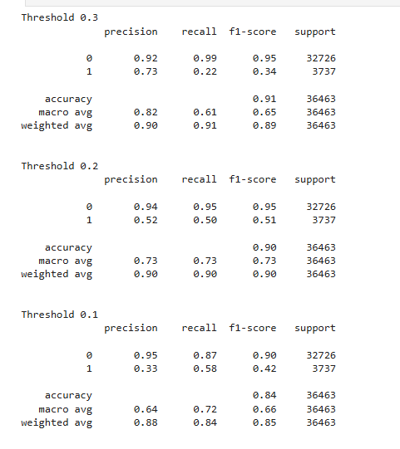
Final XGBoost Model (Tuned)
The XGBoost model is trained using the best hyperparameters obtained from tuning.
Best Parameters:
- max_depth = 3
- learning_rate = 0.05
- n_estimators = 200
Threshold is adjusted to 0.2 to balance precision and recall.
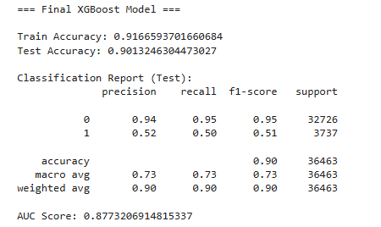
ROC curve
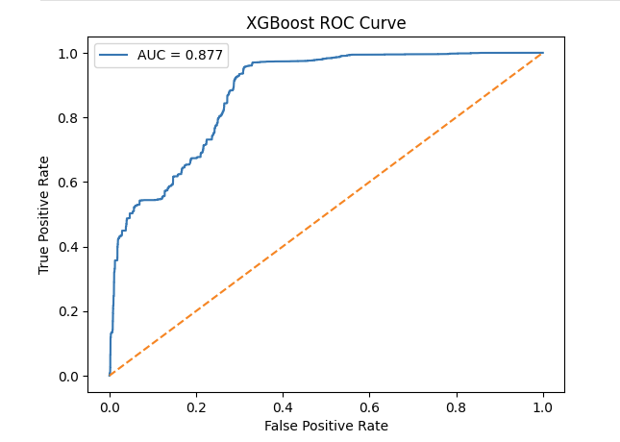

CONFUSION MATRIX
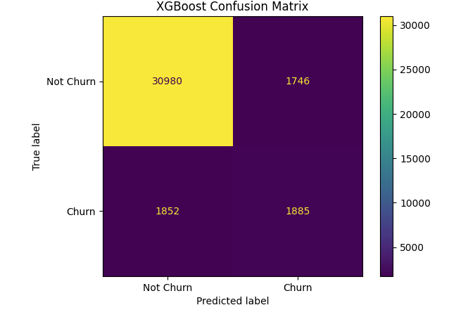

Random Forest Model (Baseline)
Random Forest is trained without hyperparameter tuning.
This serves as a baseline ensemble model.
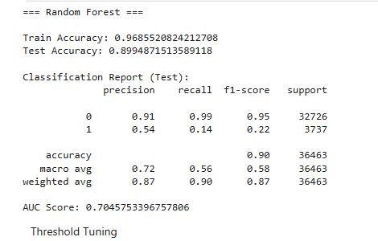

Threshold Tuning

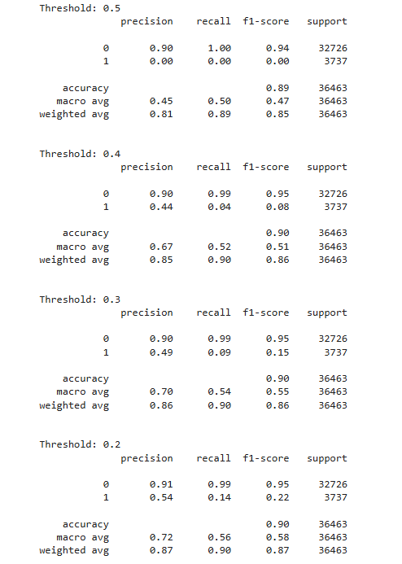
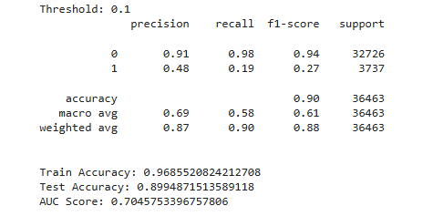

Hyperparameter Tuning For Random Forest
1.Manual Tuning
Best Params: (5, 200, 5, 1)
Best F1: 0.6540785498489426
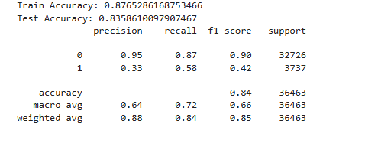
- GridSearch CV
Best Params: {'max_depth': 5, 'min_samples_leaf': 2, 'min_samples_split': 5, 'n_estimators': 100}

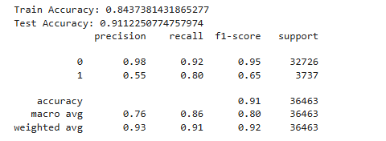

ROC Curve
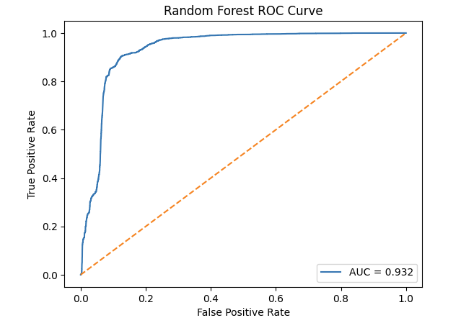
Confusion Matrix
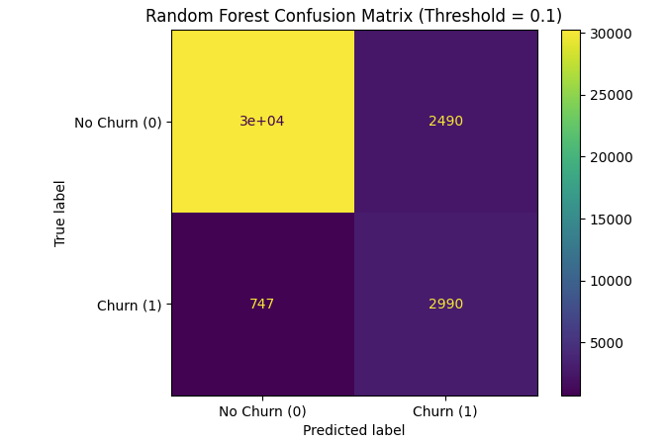
18.MODEL EXPLAINABILITY:
1.XGBoost Explainability
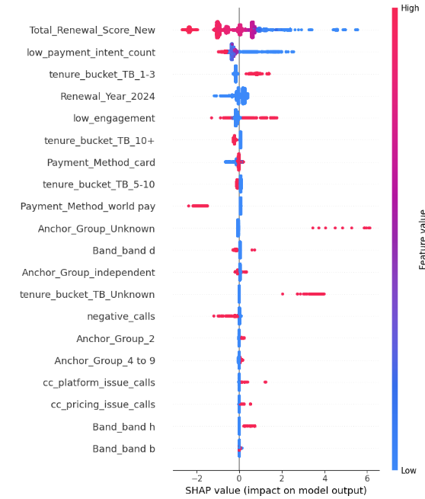
SHAP Summary Plot Interpretation
The SHAP summary plot shows the impact of each feature on churn prediction at an individual customer level. Each point represents a customer. The x-axis shows the SHAP value, indicating whether the feature increases or decreases churn probability. Red indicates high feature values and blue indicates low feature values.
Feature-level Insights
Total_Renewal_Score_New Low values strongly increase churn probability, while high values reduce churn. Customers with low renewal scores are highly likely to churn. Business should improve renewal experience and provide incentives before renewal.
low_payment_intent_count Higher values increase churn probability. Customers showing low payment intent are at high risk. Business should implement early reminders and flexible payment plans.
tenure_bucket_TB_1-3 Customers in early tenure stages (1–3 months) have higher churn risk. New customers are more likely to churn. Business should focus on onboarding and early engagement strategies.
Renewal_Year_2024 Shows variation indicating time-based or seasonal effects in churn behavior. Churn patterns may vary across different time periods.
low_engagement Higher values increase churn probability. Customers with low engagement are highly likely to churn. Business should improve engagement through campaigns, notifications, and personalized communication.
tenure_bucket_TB_10+ Higher tenure reduces churn probability. Long-term customers are more stable and less likely to churn.
Payment_Method_world pay Certain payment methods show higher churn association. Possible payment friction or usability issues may exist.
Anchor_Group_Unknown Customers with unknown grouping show high churn risk. These customers may lack proper segmentation or engagement.
negative_calls Higher number of negative interactions increases churn probability. Customer dissatisfaction is a major driver of churn. Business should improve support quality and reduce negative experiences.
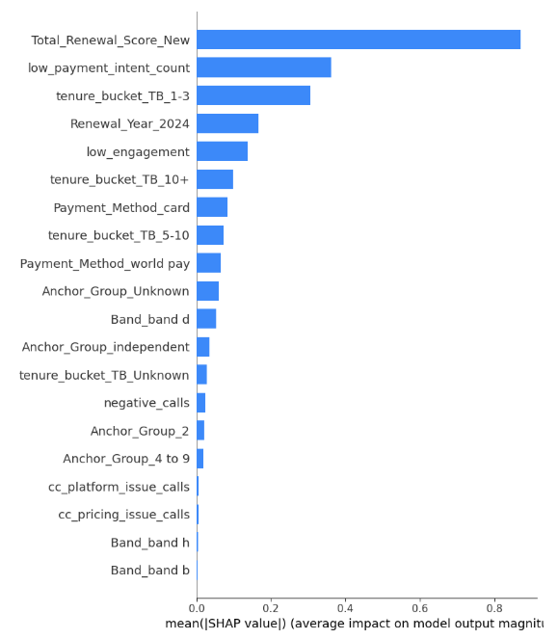
SHAP Bar Plot Interpretation
The SHAP bar plot shows the average importance of each feature across all predictions. It does not indicate direction, only the magnitude of influence.
Key Insights
Total_Renewal_Score_New The most important feature overall, indicating renewal behavior is the primary driver of churn.
low_payment_intent_count Second most important feature, showing payment behavior strongly influences churn.
tenure_bucket_TB_1-3 Early-stage customers contribute significantly to churn.
Other Important Features Low engagement, payment method, tenure buckets, and interaction-related features also contribute meaningfully.
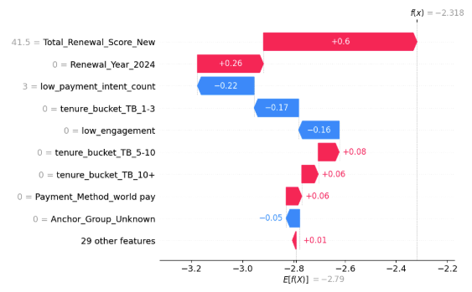
SHAP Individual Prediction (Waterfall Plot)
This plot explains how the model arrived at a prediction for a single customer. It shows how each feature contributes to pushing the prediction toward churn or non-churn.
The baseline value represents the average prediction across all customers. Each feature then adds or subtracts from this baseline to reach the final prediction.
- Red bars increase the prediction value (push towards churn)
- Blue bars decrease the prediction value (push towards non-churn)
Interpretation of This Customer
The final prediction value is lower than the baseline, indicating that the model predicts this customer is less likely to churn overall.
Feature-level Explanation
Total_Renewal_Score_New = 41.5 (+0.60) This is the strongest contributing feature for this customer. It significantly increases the prediction value, meaning this feature pushes the model toward predicting churn.
Renewal_Year_2024 = 0 (+0.26) This also increases churn probability moderately. It indicates that based on the model’s learned patterns, this value contributes to higher churn risk.
low_payment_intent_count = 3 (−0.22) This reduces churn probability. For this customer, payment intent appears to be relatively stable compared to others.
tenure_bucket_TB_1-3 = 0 (−0.17) This indicates the customer is not in the early tenure bucket. This reduces churn risk, meaning longer-tenure customers are more stable.
low_engagement = 0 (−0.16) This shows the customer is not classified as low engagement. Higher engagement reduces churn probability.
tenure_bucket_TB_5-10 = 0 (+0.08) This slightly increases churn probability. This suggests that customers in other tenure groups may have slightly higher churn risk.
tenure_bucket_TB_10+ = 0 (+0.06) Also slightly increases churn probability. This indicates the customer is not in the most stable long-tenure group.
Payment_Method_world pay = 0 (+0.06) This contributes slightly to increased churn risk. It may reflect differences in payment behavior across methods.
Anchor_Group_Unknown = 0 (−0.05) This slightly reduces churn probability. The customer belongs to a known group, which is generally more stable.
Other features (+0.01 combined) All remaining features together have minimal impact on the prediction.

Combined Insights and Business Understanding
From all three SHAP plots, we can clearly understand why customers are churning and what factors are most important.
The same few features keep appearing again and again, which means they are truly important.
Simple Understanding
Customers are more likely to churn when:
- Their renewal score is low
- They are not interested in paying or renewing
- They are new customers (first few months)
- They are not engaging much
- They have had negative experiences
At the same time, customers are less likely to churn when:
- They are engaged
- They have been with the company for a long time
- They show good payment behavior
What we learned from all plots together
- Renewal score is the biggest factor. If it is low, churn risk is very high
- Payment intent gives an early signal before churn actually happens
- New customers are the most risky group
- Engagement is very important. Less engagement means higher churn
- Bad customer experience directly leads to churn
Also, one important thing is:
Churn is not caused by just one reason. It is a combination of multiple small factors.
Business Interpretation
In simple terms, customers leave when:
- They don’t feel connected to the product
- They don’t see value in renewing
- They face issues (payment, support, experience)
Customers stay when:
- They are actively using and engaging
- They have a smooth experience
- They trust the service
Recommendations
- Focus more on new customers Make sure they get a good onboarding experience Keep them engaged in the first 1–3 months
- Improve renewal process Give reminders, offers, or incentives before renewal
- Track payment behavior If someone is delaying or not interested in paying, reach out early
- Increase engagement Use emails, messages, or offers to keep customers active
- Improve customer support Reduce complaints and fix issues faster

Final Thought
Customers don’t leave randomly. They give signals before leaving.
If the business tracks these signals early, it can reduce churn significantly.

Logistic Regression Explainability
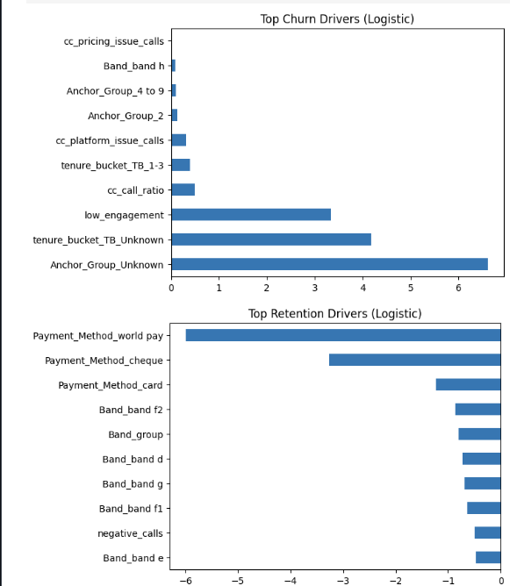
Logistic Regression Insights (Simple Explanation)
What increases churn
The model shows that the following factors strongly increase the chance of churn:
- Anchor_Group_Unknown Customers who are not clearly categorized or grouped have a very high chance of churning. This usually means the business does not understand or track them well.
- tenure_bucket_TB_Unknown If customer tenure is unknown or unclear, churn risk is high. This again points to data gaps or weak customer tracking.
- low_engagement Customers who are not actively engaging are very likely to churn. This is one of the most important and expected drivers.
- cc_call_ratio and issue-related calls Higher call ratios and platform/pricing issue calls increase churn. This suggests that customers who contact support more (especially with issues) are unhappy.
- tenure_bucket_TB_1-3 New customers (first few months) are more likely to churn, which aligns with earlier findings.
- Anchor groups and certain bands Some customer segments show slightly higher churn, but their impact is smaller compared to engagement and renewal-related factors.
What reduces churn
The following factors reduce churn risk:
- Payment methods (card, cheque, world pay) Customers using structured or stable payment methods are less likely to churn. This shows that smooth and reliable payment experience improves retention.
- Band categories (d, e, f1, f2, g, etc.) Certain customer segments are more stable and less likely to churn. These are likely well-established or high-value users.
- Band_group Being part of a defined group reduces churn, meaning proper segmentation helps retention.
- negative_calls This appears as reducing churn, which may seem unexpected. It could mean that customers who raise issues are still engaged and trying to resolve problems instead of leaving immediately.
Overall understanding
From Logistic Regression, we can clearly see that churn is mainly driven by:
- Lack of engagement
- Lack of proper customer information or grouping
- Customer issues and dissatisfaction
- Early stage in customer lifecycle
At the same time, churn reduces when:
- Customers have stable payment behavior
- Customers belong to known segments
- Customers are more structured and trackable
Business interpretation
In simple terms:
Customers leave when the business does not understand them well, they are not engaged, or they face issues.
Customers stay when they are properly categorized, actively engaged, and have a smooth experience, especially in payments.
Recommendations
- Improve customer tracking and segmentation Avoid having "unknown" groups. Every customer should be clearly categorized.
- Focus on engagement Identify low-engagement users early and re-engage them through communication or offers.
- Improve support experience Reduce platform and pricing issues that lead to dissatisfaction.
- Strengthen onboarding New customers need extra attention in the first few months.
- Ensure smooth payment systems Stable and easy payment methods help retain customers.
Final note
These insights from Logistic Regression match closely with what we saw in XGBoost SHAP analysis.
This confirms that the identified churn drivers are reliable and consistent across models.

